# **How To Make Wrapped Candy In Candy Crush**

**If you have been trying to figure out how to earn more points by making wrapped candies in Candy Crush, you will be happy to know that you can make Wrapped Candy when you match five candies in an L, T, + or, † shape*.***

While Candy Crush is one of the most played online games, some levels can be very challenging, especially if you get to the higher levels. It is often necessary to create special types of candies to earn more points and easily move up a level.

To do this, one of the candies you should learn to make is Wrapped, Candy. Did you know, for instance, that you need wrapped candy to unlock new orders when you reach level 7899? Read o to find out how to make wrapped candy.

## **How to make the wrapped candy**

You can make wrapped candies in a few ways, and we’ll share these proven ways of making more.

But before we do, it is worth noting that while it’s impossible to create the wrapped candy directly through the formation of the + shape in just one switch, you can create something close to a + shape or, rather, a shape that looks more like a cross. Think of this strategy as creating somewhat of a + shape, but in a T shape, with one candy on top of the T shape. So, not a + but a † shape. You would do this with candies in two colors.

### **Steps for making wrapped candy**

1. First, open your Candy Crush app, then start the game.
2. Next, look out for the 5 identical color candies. While doing this, remember that you can only make a piece of the wrapped candy by carefully organizing the candies and ensuring they form either the + sign or the † shape.
3. Next, swipe all the candies adjacent to it so that all the matching pieces are in the recommended shapes above. Besides the two shapes above, you could also organize the candies in a T or an L shape. While it sounds easy, you may have to play this level for quite a while. You may also have to shuffle several candy pieces a few times before placing the candies in the desired shape.
4. Make sure that you have the candies in the ideal shape recommended above. Once you shuffle the candies and place them in the correct order, you will not just make the wrapped candy but also earn up to 200 points. So, to earn these points, keep swiping all the adjacent candies away until you attain the desired L or T shape.
5. Now that you have a wrapped candy, you can experience its power and special effects. The simplest of these explosions comes from activating the wrapped candy using a 3-piece candy combo that will earn you 540 additional points and an explosion. For these explosions, you must match the wrapped candy with two similar and regular candies or two candies belonging to the same family. When this happens, you'll have an explosion that will quickly clear out 9 candies surrounding the primary Wrapped Candy.

## **Which candy combos make Wrapped candy?**

Learning the candy combinations that create wrapped candies will help you earn more points, unlock new orders and levels, and save you when you feel stuck.

Remember that the 5 or 6 candies that create the wrapped candy should be identical to create the magical wrapped candy.

Note that while you could create wrapped candy by directly matching the candy, the wrapped candy you create will replace all the matched candies you'll have switched out. If, on the other hand, you create the candy in a cascade, the wrapped candy created replaces any of the other candies that were cleared.

## **What are the common combinations of wrapped candy?**

While a 5-piece identical candy match organized in an L, T, +, or † shape creates one wrapped candy, you should also know that there are certain candy and wrapped candy combinations that will create fun explosions, exploding the wrapped candy and two or even 9 candies surrounding the wrapped candy. These will also earn you several points.

### **Wrapped candy + Color Bomb**

One of the most common candy combinations involving wrapped candy is the color bomb and wrapped candy combinations. When these two candies combine, all the candies in the same color as the wrapped candy form a new wrapped candy, and all the candies are activated. And this doesn’t just apply to the standard candies in the same color as the created wrapped candy, but also all other special candies, Marmalade, and the Liquorice Locks.

So, it’s safe to say that you can create an additional wrapped candy when you combine a wrapped candy with a color bomb or a special candy.

### **Two Wrapped Candies**

Note that two wrapped candies will create double the usual effect, with a blast range of 5*5. The wrapped candy is more valuable than the striped candy.

## **Candy Combinations and Points Earned**

|  |  |
| --- | --- |
| **Candy Combinations (On Mobile)** | **Scored Points/ Effect** |
| 2 wrapped candies with top tiles | 1440 |
| 2 wrapped candies for tiles at the bottom | 2880 |
| 2 wrapped candies for tiles near the tiles at the bottom | 1980 |
| 1 wrapped candy + 2 similar colored candies | 540 |
| Color bomb + wrapped candy | Candies in same color as wrapped candy turn into wrapped candies, then they are activated. |

## **Conclusion**

Wrapped candy is one of the special candies in Candy Crush. But you need a specific strategy to create this candy and, later, to activate it. To create a Wrapped Candy, you have to match 5 or 6 regular candies and then organize them in T, L, +, or † shapes; but only if the combination of candies doesn’t form the color bomb.

## **FAQs**

**Can you create or detonate the Wrapped Candy randomly?**

Yes, you can. To do this, you need to activate UFO. If timed correctly, all the Extra Time candy pieces turn to Wrapped Candies on Sugar Crush.

**Do wrapped candy explode more than twice?**

Yes, this could happen when there are long cascade chains. The cascade chain comprises 5 candies on mobile phones or 3 in web formats.

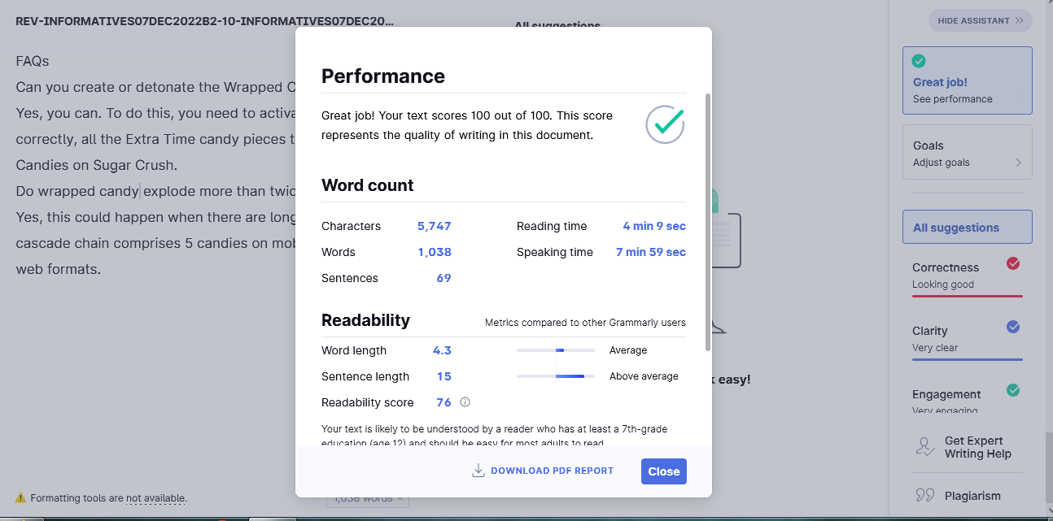

**Editor’s Report**

|  |  |
| --- | --- |
| **Specific Client Instructions** | **Editor’s Comments** |
| Target answer | present |
| Introduction | Well covered |
| Subheadings | Relevant to the topic |
| Overall quality | Great |